Team ID :PNT2022TMID50033

Project Name :Real-Time Communication System Powered By AI For Specially Abled.

**C.Thanalakshmi**

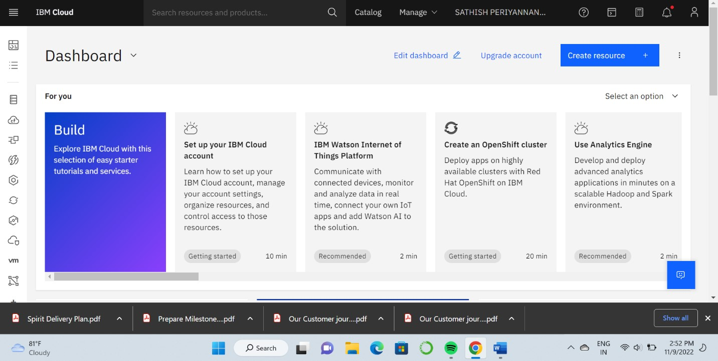

# M.Subalakshmi

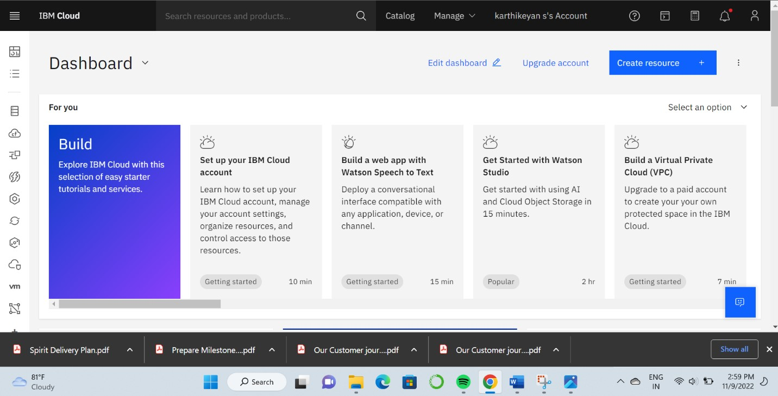

# T.Mahalakshmi

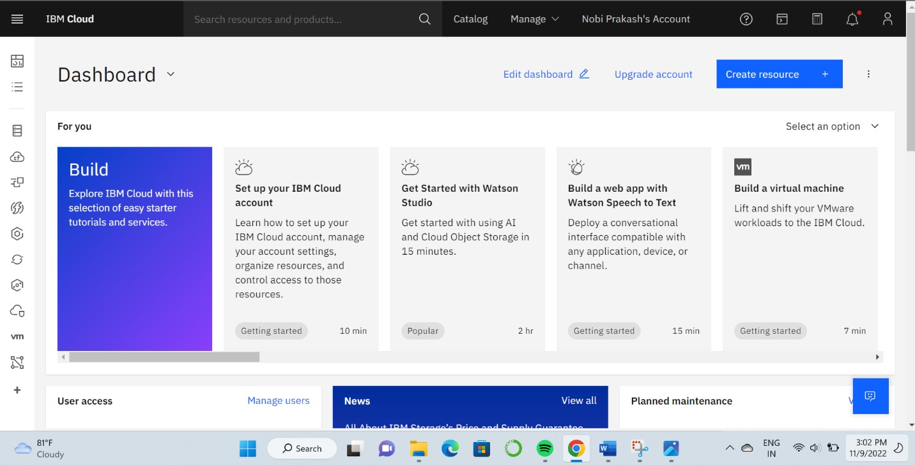

# P.Velvalli

